Quito on January 5, 2021

Ms,

Mireya Carolina Navas Morales

INTENTION LETTER

Dear Mrs. Mireya Navas with identity card 1709490492 owner of the mini-market "San Juan", this letter of intent is to express our interest in implementing a billing system in your mini-market, for which we will sponsor our project below :

1. Design of a billing system in which it shows an easy handling when billing a product, the entry of different suppliers and items, as well as the entry of new clients that once they are registered in the system to later have your data saved and not re-enter it.

2. Redesign of the way in which it is invoiced until today since with this method the loss of information is much higher and it is not possible to have accurate and timely information about the sales that the store has.

3. Minimize the risks of loss of company data, also promote savings in resources because with online invoices we avoid the use of paper, ink and time.

4. Encourage saving time for staff in a certain process and thus increase the productivity of the company.

5. We offer better business management, better business administration regarding the status, stock of the store's products, thus making it faster and more fluid when placing an order and making the invoice.

We consider that this project is what the company requires for the renewal of its billing process and its effectiveness.The developers that are part of this team are:

* Erika Achig

[emachig@espe.edu.ec](mailto:emachig@espe.edu.ec)

* Angel Aguire

[aeaguirre2@espe.edu.ec](mailto:aeaguirre2@espe.edu.ec)

* Carolina Alvarado

[ecalvarado@espe.edu.ec](mailto:ecalvarado@espe.edu.ec)

* Bryan Azuero

[beazuero@espe.edu.ec](mailto:beazuero@espe.edu.ec)

* Bryan Castro

[bpcastro1@espe.edu.ec](mailto:bpcastro1@espe.edu.ec)

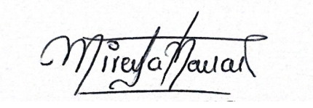

Ing. Mireya Navas

CI. 1709490492